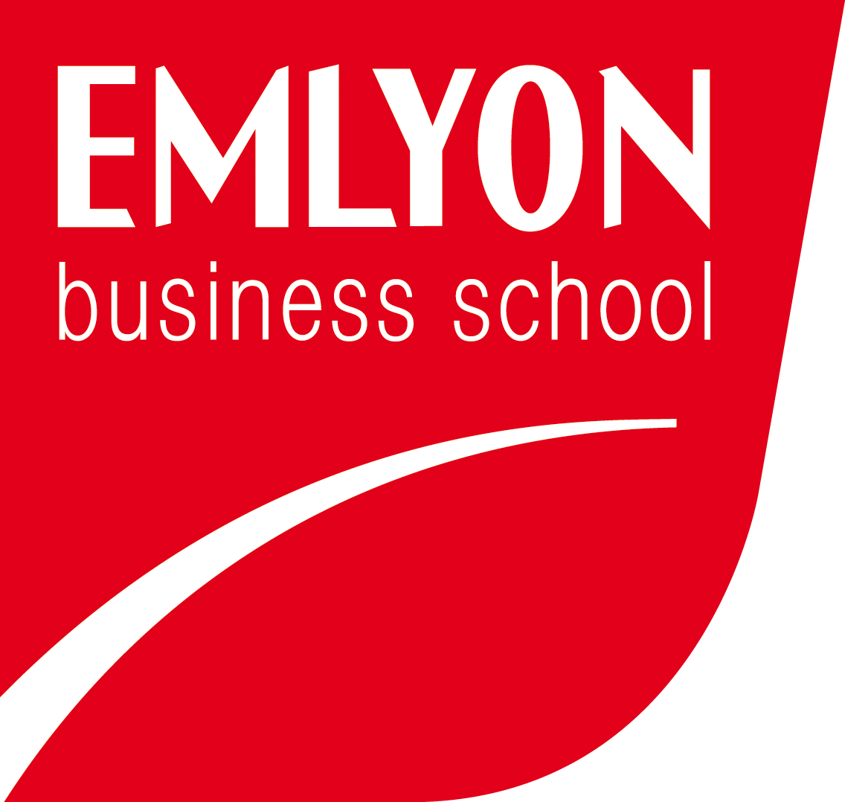
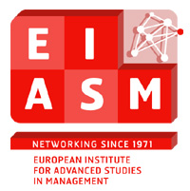

11th Workshop on Family Firm Management Research
Shifting Boundaries in Family Firm Research

Lyon, France, May 29-30, 2015

28th MAY

18.30 – 20.00: Drinks reception
LYINC CLUB (International club)
2, Place de la bourse. Lyon 69002.

29th MAY

08.00 - 16.00: Registration

08.30 - 08.45: Intro and welcome
Celina Smith, Leif Melin
Bernard Belletante, Dean EMLYON Business School
Alain Fayolle

08.45 - 09.30: First keynote speaker:
Prof. Howard Aldrich (University of North Carolina).
Title of Keynote lecture: Mauled by the Market: Why capitalism threatens the future of “family business”

09.30 - 10.00: Coffee break

10.00 - 11.30: Parallel Tracks

Track 1: ROOM 1106
Family Firms Across Generations I
(Chair, Mira Bloemen-Bekx, Windesheim University)

- Paper ID. 32930 - Disentangling the deep rooted family influence on entrepreneurship in family firms across generations. Badal-Damen, Mariette Maria Petronella (Avans University of Applied Sciences).
- Paper ID. 32932 - Making the transition: rethinking what we know and don't know about the next generation and family business. Mc Elhinney, Catherine (University College Dublin) & Maeve Houlihan.
- Paper ID. 32972 - To be or not to be a future family business leader: the emotional ambivalence of next generation members. Radu Lefebvre, Miruna (Audencia Nantes School of Management) & Valérie Denis.

Track 2: Room 1108
New Boundaries Research I
(Chair, Alain Fayolle, EMLYON Business School)

- Paper ID. 32419 - An exploration of the shifting fields of family and business: How Bourdieu’s sociological theories can help us to understand family firms. Salmon, Udeni (University Of Salford).
- Paper ID. 32884 - Extending the boundaries of family entrepreneurship research through family entrepreneurial teams. Discua Cruz, Allan Fernando (Lancaster University), Elias Hadjielias & Carole Howorth.
- Paper ID. 46064 - Extending the family to business support perspective through the lens of social exchange theory. Theororakopoulos Nicholas (Aston Business School) & Mark Hart.

Track 3: Room 1110
Corporate Social Responsibility
(Chair, Ethel Brundin, Jönköping International Business School)

- Paper ID. 32873 - Are family firms and non-family firms different in approaching CSR? An integrated framework about why and how family firms engage in it. Ciaburri, Mirella (Luiss University), Maria Federica Izzo & Riccardo Tiscini.
- Paper ID. 32927 - Social responsibility in family businesses: a meta-system perspective. Ramirez-Pasillas, Marcela (Jönköping International Business School), Olof Brunninge & Markus Plate.
- Paper ID. 32961 - The influence of family involvement on SMEs social performance and downsizing. A stakeholder identity orientation perspective. Kocollari, Ulpiana (University Of Modena and Reggio Emilia), Stefano Montanari & Paolo Di Toma.

11.30 - 13.00: Parallel Tracks

Track 4: Room 1106
Corporate strategies and performance
(Chair, Frank Hermann, Vienna University of Economics and Business)

- Paper ID. 32870 - Downsizing in owner-managed companies: an examination of the financial and economic crisis in Germany. Ludwig, Daniel (University Of Siegen), Andreas Dutzi & Holger Reinemann.
- Paper ID. 32971 - To ally, acquire, or merge: a duality perspective on the role of ownership in pre-acquisition choices in family firms. Kumeto, Gershon (Jönköping International Business School).
- Paper ID. 32967 - Relevance of accounting performance measures under IFRS: the case of quoted family firms. Basly, Sami (Paris X Nanterre University) & Saadi Tayeb.

Track 5: Room 1108
Boards of private family firms
(Chair, Discua Cruz, Allan Fernando, Lancaster University)

- Paper ID. 32925 - Duty of care to the firm: how do non-executive directors navigate their role conflicts on boards of private family firms. Kirwan, Collette (University College Dublin) & Niamh M. Brennan.
- Paper ID. 32965 - Strategic practices in family businesses: the case of advisory boards. Van Helvert-Beugels, Judith (Windesheim University) & Mattias Nordqvist.

Track 6: Room 1110
Managerial practices and succession
(Chair, Udeni Salmon, University Of Salford)

- Paper ID. 32977 - Family values as a driver of managerial practices and business culture. Heetebrij-Van Dalfsen, Roeline Margré (Windesheim University) & Ilse A. Matser.
- Paper ID. 32688 - In mother's shadow. How to overcome obstacles to mother-daughter business transmission. Ferrari, Filippo (University of Venice).

13.00 - 14.00: LUNCH

14.00 - 15.30: Parallel Tracks

Track 7: Room 1106
New boundaries research II
(Chair, Discua Cruz, Allan Fernando, Lancaster University)

- Paper ID. 32970 - Kind of kin – towards a fluid definition of ‘family’ in ethnic minority family businesses. Achtenhagen, Leona (Jönköping International Business School).
- Paper ID. 32938 - The family business as a structurally shame-prone organization. Plate, Markus (Jönköping International Business School).
- Paper ID. 32980 - The social activities of family firms and their owners: Building on social entrepreneurship research. Rottke Becker, Olaf Matthaeus (Complutense University Of Madrid) & Wolfgang Spiess Knafl.

Track 8: Room 1108
Family Firms Across Generations II
(Chair, Valérie Denis, Ichec Brussels Management School)

- Paper ID. 32849 - Following into your parents’ footsteps? The impact of family occupational background on career intentions of young adults. Bloemen-Bekx, Mira (Windesheim University) & C. Remery.
- Paper ID. 32948 - Maintaining trust over generations in multiple family branches family firms: a group-based approach. Mari, Isabelle (Jönköping International Business School).
- Paper ID. 32960 - Shifting boundaries in family firms – Perception of new generation family firms owners. Bernatovic, Ivija (Zagreb School of Economics and Management), Mirna Korican Lajtman & Goran Oblakovic.

Track 9: Room 1110
Financial management
(Chair, Myriam Lyagoubi, EMLYON Business School)

- Paper ID. 32963 - Family influence on corporate tax planning. Kaiser, Stefanie (Whu-Otto Beisheim School of Management), Martin Glaum & Katrin Haussmann.
- Paper ID. 32958 - How do they manage? Shifting boundaries in financial management research of family firms. Kuhl, Aniela (University of Strathclyde) & Sara Carter.
- Paper ID. 32886 - Socioemotional wealth, tax considerations and family firm payout decisions. Deslandes, Manon (University of Québec In Montréal), Suzanne Landry & Anne Fortin.

15.30 - 16.00: COFFEE BREAK

16.00 - 17.30: Parallel Tracks

Track 10: Room 1106
Innovation
(Chair, Andreas Dutzi, Siegen University)

- Paper ID. 32944 - Innovation research in the family business field: are we building an ivory tower? Fuetsch, Elena (Vienna University of Economics and Business) & Julia Suess-Reyes.
- Paper ID. 32966 - Product/service innovation, family ownership and management: Evidence from an innovation survey in Spain". Bikfalvi, Andrea (University of Girona), Josep Llach, Pilar Marques & Alexandra Simon.
- Paper ID. 32951 - The role of financial constraints in explaining innovative behavior of private family firms. Creemers, Sarah (Hasselt University), Wim Voordeckers & Mark Vancauteren.

Track 11: Room 1108
Internationalization
(Chair, Jean-Luc Arregle, EMLYON Business School)

- Paper ID. 32883 - A behavioral approach to non-linear internationalization of family firms. Kuiken, Andrea (Jönköping International Business School) & Lucia Naldi.

- Paper ID. 46034 - Does ownership Structure influence firm's internationalization? The case of listed firms in France. Basly, Sami (Paris X Nanterre University) & Souha Ghariani.
- Paper ID. 32917 - Family firms, symbolic capital and venturing processes: Evidence from five Italian case studies. Brumana, Mara (University of Bergamo), Tommaso Minola & Mattias Nordqvist.

Track 12: Room 1110
Emotions
(Chair, Etienne Borg Cardona, University of Malta)

- Paper ID. 46056 - Should I laugh or should I cry? An emotion perspective on work-family boundaries in family firms. Brundin Ethel (Jönköping International Business School) & Jean Charles Languilaire.
- Paper ID. 46062 - The role of emotional network reproduction and network learning in creating social reciprocity. Ucha Placke Jennifer (Edinburgh Napier University), Simon Gao, Brian Windram & Blair Winsor

19.30 - 23.00: Gala dinner – boat trip around the Rhone & Soane

30th MAY

08.30 - 08.45: Opening words and welcome

08.45 - 09.30: Second keynote speaker:
Prof. Nadine Kammerlander (University of St. Gallen)

09.30 - 10.00: COFFEE BREAK

10.00 - 12.00: Parallel Tracks

Track 13: Room 1106
Legal & ownership aspects
(Chair, Leif Melin, Jönköping International Business School)

- Paper ID. 32918 - Foundation owned firms in Germany: A field experiment for agency theory. Draheim, Matthias (Konstanz University) & H.C. Günter Franke.
- Paper ID. 32956 - Keeping family business alive? The rise of foundation-owned firms in Germany. Kaufmann, Guido (University of Siegen), Andreas Dutzi & Patrick Werner.
- Paper ID. 32905 - Ownership rights of children in family firms: At the boundaries of law and business. Haag, Kajsa (Jönköping International Business School), Lars-Göran Sund & Jean-Charles Languilaire.
- Paper ID. 32289 - The impact of new family business legislation on boundaries between family and non-family ownership and control in family businesses in Malta. Borg Cardona, Etienne (University of Malta).

Track 14: Room 1108
Exit strategies and firm performance
(Chair, Zied Guedri, EMLYON Business School)

- Paper ID. 32947 - Did the economic crisis increase the intention to sell the family firm? A study of a French SMEs sample. Basly, Sami (Paris X Nanterre University).
- Paper ID. 32955 - Family business exit and the effectiveness of corporate governance. Di Toma, Paolo (University of Modena and Reggio Emilia) & Stefano Montanari
- Paper ID. 32916 - Going private: why family controlled, publicly-listed companies decide to leave the stock-exchange. Boers, Börje (Jönköping International Business School), Torbjörn Ljungkvist, Olof Brunninge & Mattias Nordqvist.
- Paper ID. 32767 - Family firms and firm performance: where do we stand? Lopez De Silanes, Florencio (EDHEC Business School) & Timothe Waxim.

Track 15: Room 1110
Socioemotional Wealth
(Chair, Mattias Nordqvist, Jönköping International Business School)

- Paper ID. 32943 - A dynamic process model of product innovation and socioemotional wealth creation in family firms. Erdogan, Irmak (Bogaziçi University).
- Paper ID. 32383 - Socioemotional wealth: Validating and re-defining the fiber scale. Hauck Jana, Julia Suess-Reyes, Susanne Beck, Reinhard Pruegl & Hermann Frank
- Paper ID. 32390 - The role of familiness and socioemotional wealth on organizational effectiveness in family firms. Barros, Ismael (University of Valladolid), Juan Hernangómez Barahona & Natalia Martín Cruz.
12.00 - 13.00: Parallel Tracks

Track 16: Room 1112
Family Business Governance
(Chair, Basly Sami, Paris X Nanterre University)

- Paper ID. 32926 - Family business governance in young family firms: A review of the first experiences of polish family firms. Koladkiewicz, Izabela (Kozminski University).
- Paper ID. 32882 - The role of non-family managers and CEOs in family firms: A critical review. Waldkirch, Matthias (Jönköping International Business School).

13.00 - 14.00: LUNCH

14.00 - 15.30: Parallel Tracks

Track 17: Room 1106
Social & psychological aspects
(Chair, Udeni Salmon, University Of Salford)

- Paper ID. 32885 - Exploring antecedents and consequences of CEOs’ psychological ownership toward change processes in family firms. Henssen, Bart (Ku Leuven Campus Brussels), Wouter Broekaert & Johan Lambrecht.
- Paper ID. 32881 - Nepotism in family businesses: boon or bane? The moderating role of nepotism in the relationship between social capital and family business performance. Schmid, Andreas (University of Zürich) & Heidi E. Bodenmann.
- Paper ID. 32952 - The role of psychological and social aspects of family capital for entrepreneurial capacity over generations. Melin, Leif (Jönköping International Business School) & Ethel Brundin.

Track 18: Room 1108
Symbolic, Reputational & status capital
(Chair, Jean-Luc Arregle, EMLYON Business School)

- Paper ID. 32874 - Communicating the ‘family firm’ status: An identity approach on branding strategy decisions of German family firms. Beck, Susanne (Zeppelin University) & Reinhard Pruegl.
- Paper ID. 32920 - Understanding the family effect on family firm reputation through a qualitative approach. Wielsma, Albertha (Windesheim University).
- Paper ID. 32959 – Family vs.no-family firm’s performance in tourism sector. Kociper, Tina (University of Maribor) & Tanja Planinc, Sasa Planinc, Gorazd Sedmak

Track 19: Room 1110
Ownership - Private equity effects
(Chair, Myriam Lyagoubi, EMLYON Business School)

- Paper ID. 32906 - Family businesses and non-family equity: a review of the current state of knowledge. Thiele, Felix (Hamburg School of Business Administration).
- Paper ID. 32863 - It’s a family affair, too! Exploring the conceptual similarities between family firms and football companies. The case of private equity investments in family firms mirrored in the outsourcing of the professional football department out of a membership association. Prigge, Stefan (Hamburg School Of Business Administration).
- Paper ID. 32974 - Working for divergent principals: effects of private equity on employment security and employment terms in family firms. Neckebrouck, Jeroen (Vlerick Business School), Sophie Manigart & Miguel Meuleman.

15.30 - 16.00: Close and introduction to EIASM 2016
Celina Smith
Mattias Nordqvist
Guest (tbc)

16.00 - 17.30: Refreshments

SCHEDULE OF DISCUSSANTS & PAPERS TO BE REVIEWED*

TRACK | DISCUSSANT | PAPER TO REVIEW
1  ROOM 1106 | BADAL-DAMEN, MARIETTE MARIA PETRONELLA | 32932
 | MC ELHINNEY, CATHERINE | 32972
 | VALERIE, DENIS | 32930
2  ROOM 1108 | SALMON, UDENI | 32884
 | DISCUA, CRUZ | 46064
 | NICHOLAS THEORORAKOPOULOS | 32419
3  ROOM 1110 | CIABURRI, MIRELLA | 32927
 | RAMIREZ-PASILLAS, MARCELA | 32961
 | KOCOLLARI, ULPIANA | 32873
4  ROOM 1106 | LUDWIG, DANIEL | 32971
 | KUMETO, GERSHON | 32967
 | BASLY, SAMI | 32870
5  ROOM 1108 | KIRWAN, COLLETTE | 32965
 | VAN HELVERT-BEUGELS, JUDITH | 32925
6  ROOM 1110 | HEETEBRIJ-VAN DALFSEN, ROELINE MARGRÉ | 32688
 | FERRARI, FILIPPO | 32977
7  ROOM 1106 | ACHTENHAGEN, LEONA | 32938
 | PLATE, MARKUS | 32980
 | ROTTKE BECKER, OLAF MATTHAEUS | 32970
8  ROOM 1108 | BLOEMEN-BEKX, MIRA | 32948
 | MARI, ISABELLE | 32960
 | BERNATOVIC, IVIJA | 32849
9  ROOM 1110 | KAISER, STEFANIE | 32958
 | KUHL, ANIELA | 32886
 | DESLANDES, MANON | 32963
10  ROOM 1106 | FUETSCH, ELENA | 32966
 | BIKFALVI, ANDREA | 32951
 | FUETSCH, ELENA | 32944
11  ROOM 1108 | KUIKEN, ANDREA | 46034
 | BASLY, SAMI | 32917
 | BRUMANA, MARA | 32883
12  ROOM 1110 | BRUNDIN ETHEL | 46062
 | UCHA PLACKE JENNIFER | 46056
13  ROOM 1106 | DRAHEIM, MATTHIAS | 32956
 | KAUFMANN, GUIDO | 32905
 | HAAG, KAJSA | 32289
 | BORG CARDONA, ETIENNE | 32918
14  ROOM 1108 | BASLY, SAMI | 32955
 | DI TOMA, PAOLO | 32916
 | BOERS, BÖRJE | 32767
 | LOPEZ DE SILANES, FLORENCIO | 32947
15  ROOM110 | ERDOGAN, IRMAK | 32383
 | FRANK, HERMANN | 32390
 | BARROS, ISMAEL | 32943
16  Room 1112 | KOLADKIEWICZ, IZABELA | 32882
 | WALDKIRCH, MATTHIAS | 32926
17  Room1106 | HENSSEN, BART | 32881
 | SCHMID ANDREAS | 32952
 | MELIN, LEIF | 32885
18  ROOM 1108 | BECK, SUSANNE | 32920
 | WIELSMA, ALBERTHA | 32959
 | KOCIPER, TINA | 32874
19  ROOM 1110 | THIELE, FELIX | 32863
 | PRIGGE, STEFAN | 32974
 | NECKEBROUCK, JEROEN | 32906

* Please note that each presenter is required to act as a discussant on a paper in their session. This entails reading the paper, preparing and providing feedback, comments or questions immediately after a presentation has been made. The time allowed for this is 5 minutes; this timing is strict and must be respected. All papers are available on the EIASM website located under ‘Download accepted papers.’ In the event that a full paper has not been provided you may provide feedback on the basis of the presentation.

